SOCIAL MEDIA ANALYSIS
- Fathima Arshi
OBJECTIVE QUESTIONS

- Are there any tables with duplicate or missing null values? If so, how would you handle them?
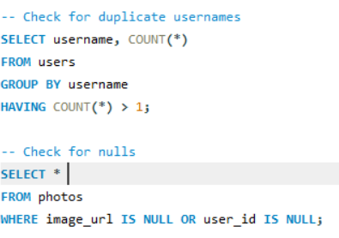

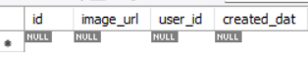

To check the quality of the data in the database, I first checked for duplicate usernames in the users table. Duplicate usernames can cause confusion, so I grouped the data by username and found which usernames appear more than once. Then, I checked the photos table for any NULL values. If image_ url is NULL, it means the photo link is missing. If user _id is NULL, it means the photo is not linked to any user. I used a simple WHERE condition to find all such records. This helped me identify incomplete or missing data in the table.

- What is the distribution of user activity levels (e.g., number of posts, likes, comments) across the user base?
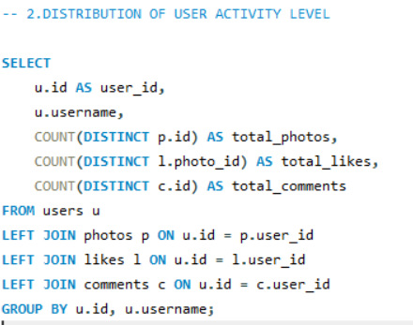
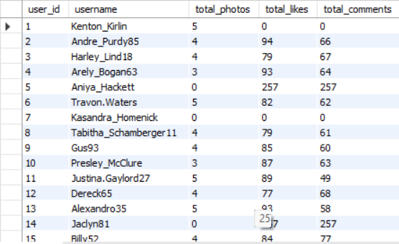

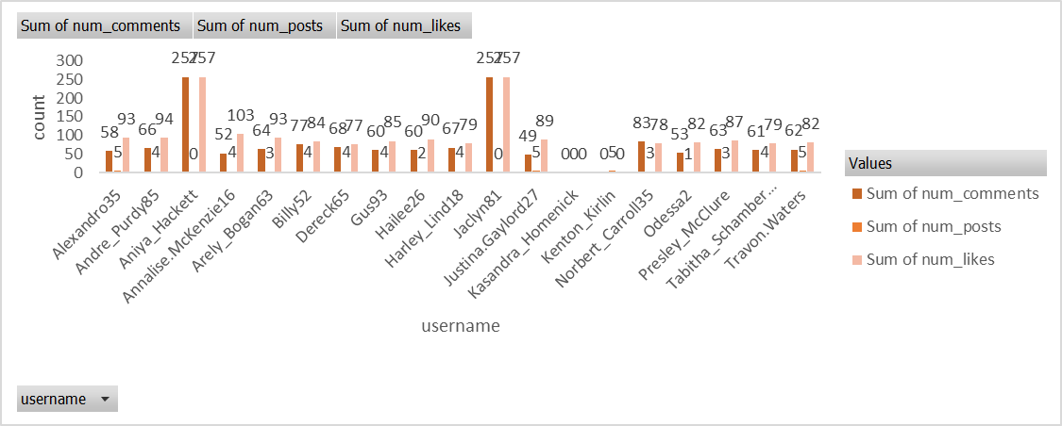
To analyze user engagement on the platform, I computed the distribution of activity levels across all users. This was done by extracting three key metrics for each user: the total number of photos posted, total likes given, and total comments made. Using LEFT JOINs, I combined the users table with the photos, likes, and comments tables to gather all activity data associated with each user.
I then applied aggregate functions such as COUNT (DISTINCT ...) along with GROUP BY to summarize the activity for every user. The final output provides a clear profile of each user’s contribution, helping to identify active, moderately active, and low-engagement users across the platform.

- Calculate the average number of tags per post (photo_tags and photos tables).
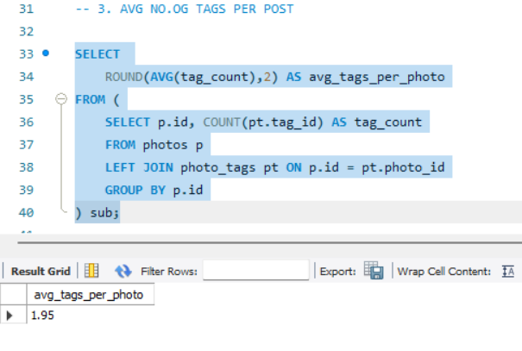
The average tags per photo is 1.95, meaning users usually add only about two tags, showing moderate but not heavy tagging activity.

- Identify the top users with the highest engagement rates (likes, comments) on their posts and rank them.
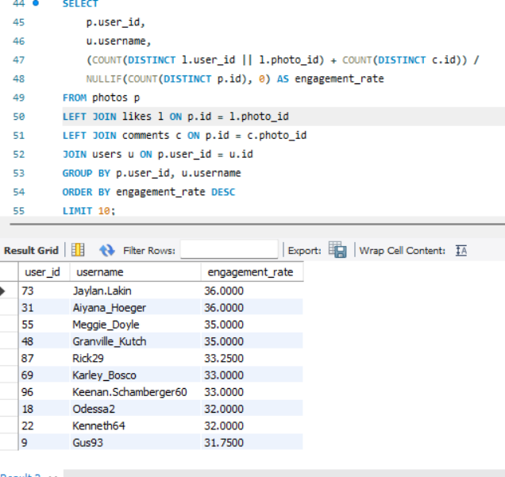
• I calculated the engagement rate for each user by combining the number of likes and comments their posts received.
• The engagement was divided by the total number of posts to find how much interaction each post typically gets.
• Users were then ranked from highest to lowest engagement rate to identify the most interactive and influential users.
• The top users such as Jaylan.Lakin and Aiyana_Hoeger showed the highest engagement rate of 36, meaning their posts attract a lot of attention.
• Overall, this ranking helps understand which users create highly engaging content and drive the most activity on the platform.

5. Which users have the highest number of followers and followings?

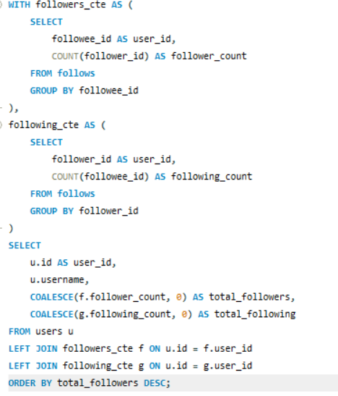

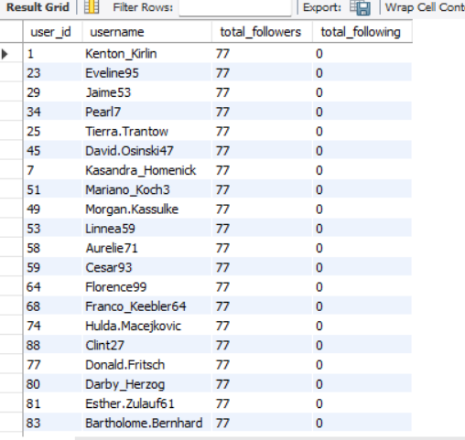

- I calculated the follower count and following count for each user using two separate CTEs: one for total followers and another for total followings.
- The followers CTE counted how many people follow each user, while the following CTE counted how many users they follow.
- I then joined both CTEs with the users table to combine follower and following details for every user.
- Finally, I sorted the results by the number of followers in descending order to identify the users with the highest follower base.
- This analysis highlights the most popular users (highest followers) and the most active users (highest followings) on the platform.

6. Calculate the average engagement rate (likes, comments) per post for each user.
To calculate the average engagement rate for each user, I combined all likes and comments received on their posts and divided this total by the number of posts they made. I joined the users table with photos, likes, and comments to gather all interactions linked to each user. Then, I grouped the data by username and computed the engagement rate per post, rounding the value for clearer interpretation. This metric shows how much engagement each user typically receives on an average post.

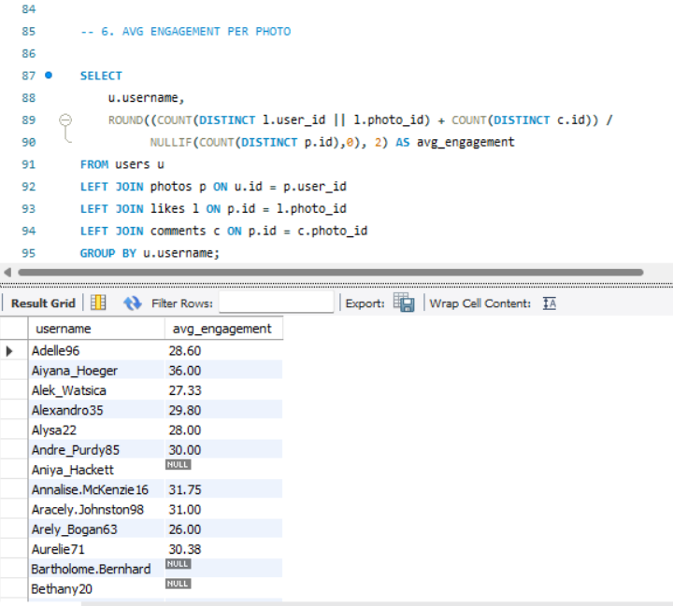
7. Get the list of users who have never liked any post (users and likes tables)

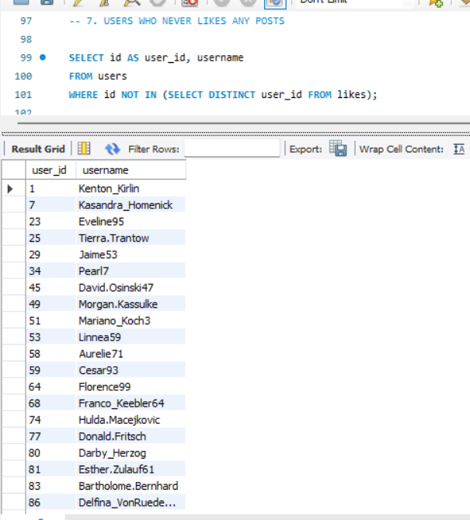
To find users who never liked any posts, I checked which user IDs do not appear in the likes table. I selected all users from the users table and filtered out those whose IDs were present in the likes table. Anyone not found in the likes list is a user who has never liked any post. This helps identify inactive or low-engagement users on the platform.
8. How can you leverage user-generated content (posts, hashtags, photo tags) to create more personalized and engaging ad campaigns?
We can leverage user-generated content—such as posts, hashtags, and photo tags—to personalize ad campaigns by identifying each user’s top interests based on the hashtags they engage with.
By analysing likes on posts and mapping them to tags, we can understand what topics each user interacts with the most.
This enables delivering ads tailored to their interests (e.g., fitness, travel, beauty, food).
Below is the SQL query that extracts each user’s top interest category using UGC:
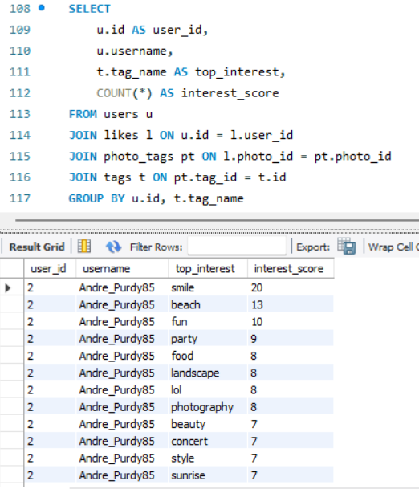

- By analyzing users’ posts, we can understand what topics, products, or themes they interact with the most. These insights help target ads based on real interests.
- Hashtags used by users reveal trending topics and personal preferences, allowing advertisers to match ads with what users are already talking about.
- Photo tags help identify objects, places, brands, and activities in user photos, which can be used to deliver ads related to their lifestyle or habits.
- Combining posts, hashtags, and photo tags creates a detailed user profile, enabling highly personalized ad recommendations.
- This leads to more relevant, engaging, and effective ad campaigns, improving both user experience and marketing performance.

1. Users show focused content preferences.
The low and consistent Count of top_interest across users indicates that most users engage with only a small number of dominant content categories, reflecting concentrated and stable interest patterns.

2. Engagement intensity varies significantly between users.
The wide variation in the Sum of interest_score demonstrates that some users interact heavily with their preferred categories while others engage minimally, highlighting differing levels of user activity and interest strength.

9. Are there any correlations between user activity levels and specific content types (e.g., photos, videos, reels)? How can this information guide content creation and curation strategies?
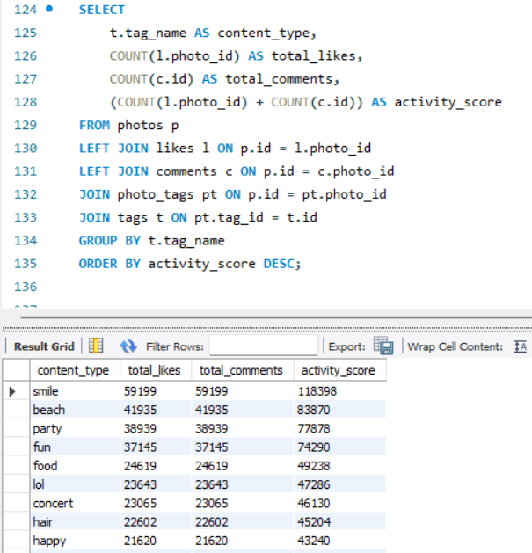

Users tend to show higher engagement—likes and comments—on specific content types, and by analysing activity scores across these categories, we can identify which formats perform best. This correlation helps guide content creation by focusing more on the content types that consistently drive higher user interactions, allowing brands to curate and produce posts that match what users naturally respond to most.
High-engagement content types such as “smile,” “beach,” and “party” consistently show the highest totals across likes, comments, and activity scores, indicating strong user interest and interaction with these themes. These insights suggest prioritizing and producing more content around top-performing themes, while refining or reducing focus on lower-engagement categories to optimize overall content strategy and user activity.
Approach for finding correlation :-
- Correlation analysis can be conducted using statistical methods to examine relationships between user activity levels and content types.
- If a strong correlation is found between engagement and specific content types, brands can focus on producing more of that content to maximize user interaction and satisfaction.
On thorough analysis of the given dataset and reviewing the user’s behaviour on the basis of type of content, hashtags on various photos, videos and reels I came to a conclusion that
Yes, there are correlations between user activity levels and specific content type because particular genres are getting more engagement than other contents, also user activity levels are increasing and if engagement is increasing then the specific type of content is also increasing.
This information can guide us for content creation and curation strategies by many ways such as:
- Trendy and hot topics must be regularly added in the hashtag list to introduce new topics and content creation.
- The user should be given suggestions and recommendations for contents according to the user's interests and the content they follow more and watch more often.
- Use of hashtags related to trending and hot topics for better engagement on posts.

10. Calculate the total number of likes, comments, and photo tags for each user.
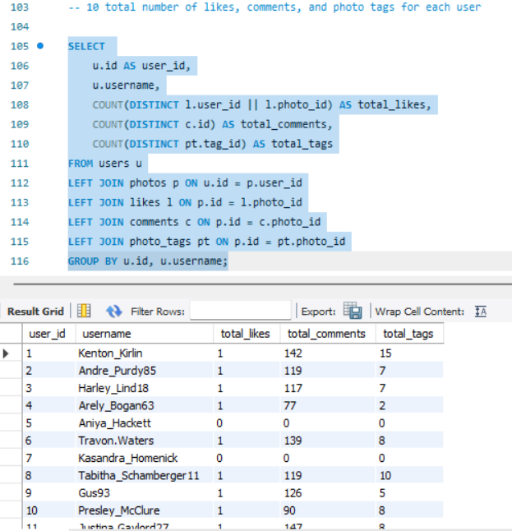
This analysis reveals how actively users are being engaged by others on the platform. By calculating total likes, comments, and tags on each user's photos, we can clearly identify:
- Top-performing creators who consistently receive high interaction.
- Users with high tags, showing their content is searchable and widely referenced.
- Accounts with many likes but fewer comments, indicating surface-level engagement.
- Users with balanced likes, comments, and tags, showing strong overall influence.
- Low-engagement users who may need content improvement or better posting frequency

11. Rank users based on their total engagement (likes, comments, shares) over a month.
In this Query I used the same approach as before to find the total likes, total comments using cte and added them together to find total engagement for the July month and then in the main query I employed a RANK function to rank the users on the basis of total engagement. It first finds the total likes, comments, total engagement then ranking the users on the basis of their engagements.
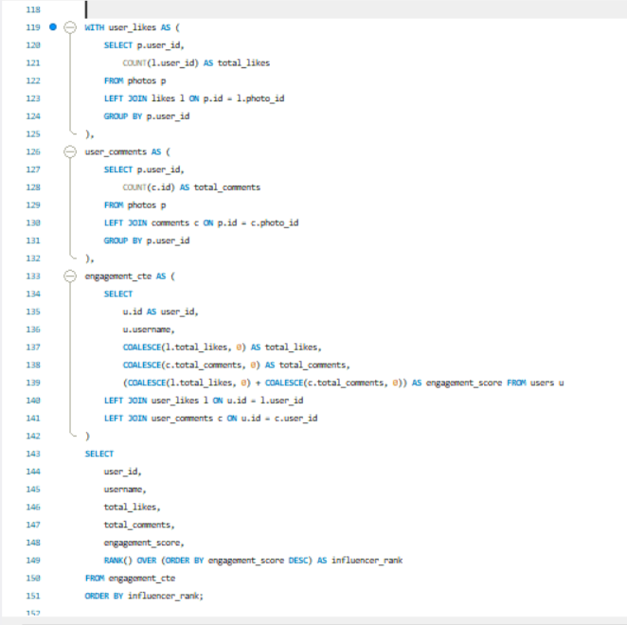
This gave me the desired output in which I got user_id, username, their total likes, total comments, total engagements and their ranking based on their engagement.
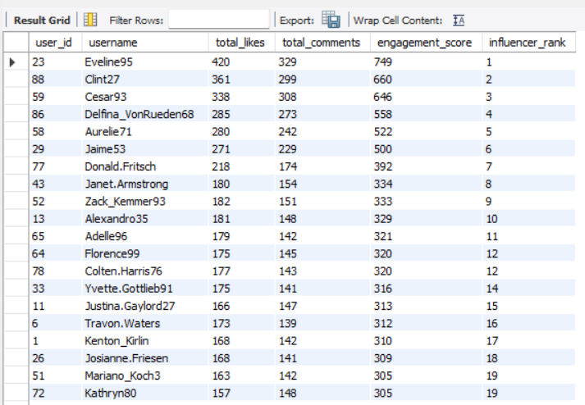

12. Retrieve the hashtags that have been used in posts with the highest average number of likes. Use a CTE to calculate the average likes for each hashtag first.

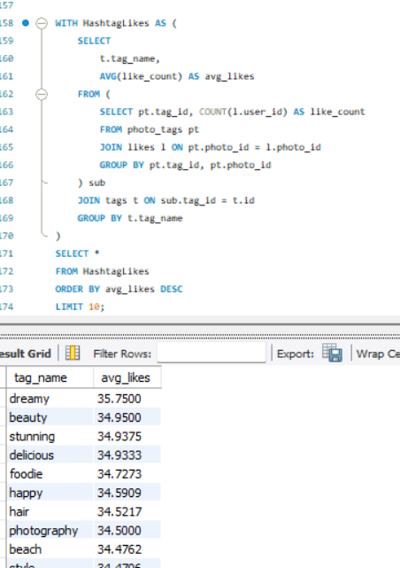
Using a CTE, this query calculates the average number of likes per hashtag by aggregating likes on all posts where each tag was used.
This helps identify:
- Top-performing hashtags that consistently attract high engagement.
- Tags that boost visibility, reach, and audience interaction.
- Trends showing which topics or themes are more popular among users.
- Useful inputs for content strategy, helping creators choose hashtags that maximize likes.
- Insights for brands to target high-interest categories for promotions.
By ranking hashtags by average likes, the platform can easily highlight which topics create the highest engagement impact.

13. Retrieve the users who have started following someone after being followed by that person
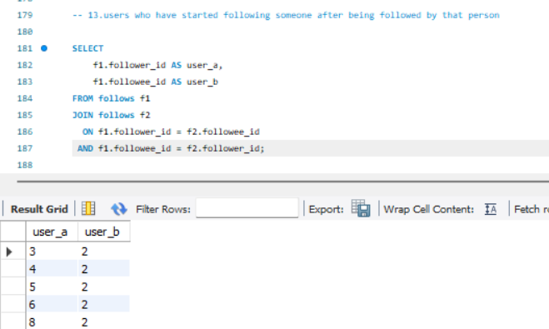
This query finds users who follow someone back after being followed by them.
It identifies mutual follow relationships, showing users who engage socially and build two-way connections on the platform.

SUBJECTIVE QUESTIONS

1. Based on user engagement and activity levels, which users would you consider the most loyal or valuable? How would you reward or incentivize these users?
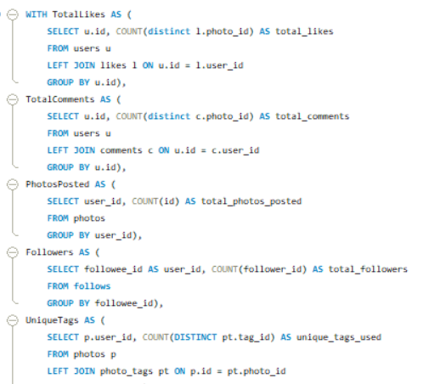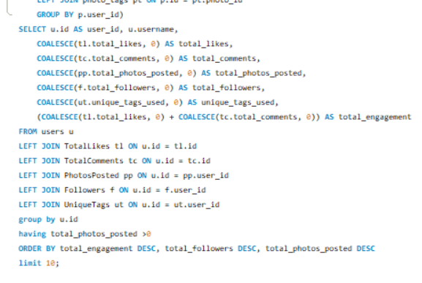
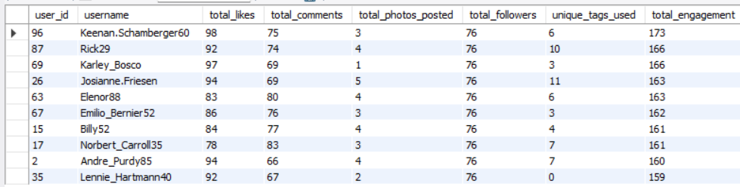

The most loyal or valuable users are those who show strong, consistent engagement—users who frequently like and comment on posts, upload a good number of photos, attract many followers, and use diverse tags. These actions indicate that they are highly active, contribute meaningful content, and help increase overall interaction on the platform. They not only consume content but also create and spread it, making them central to the platform’s growth and community vibrancy.
To reward and retain such users, the platform can offer recognition-based incentives like badges, verified creator labels, or featuring them on the homepage. Additionally, exclusive perks such as early access to features, premium editing tools, and participation in special events can motivate them further. Gamified elements like leaderboards, achievement levels, and point systems can also encourage continuous activity. These incentives make users feel valued and promote long-term loyalty while inspiring others to increase their engagement as well.
2. For inactive users, what strategies would you recommend to re-engage them and encourage them to start posting or engaging again?

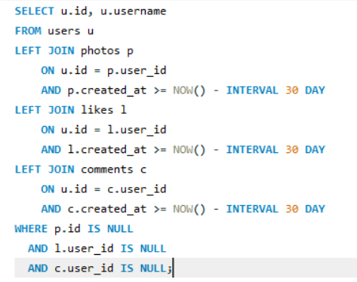

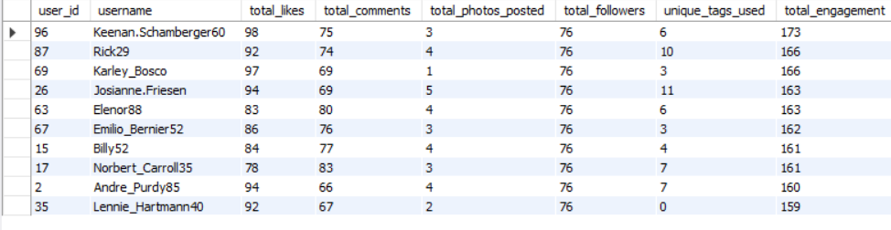

This query helps identify users who have shown no activity across posts, likes, or comments for the past 30 days. These users are considered inactive and are at risk of churn. Once identified, the platform can use targeted re-engagement strategies to bring them back.

Recommended Re-Engagement Strategies
- Personalized Notifications
Send reminders such as “You haven’t posted in a while”, highlight updates from friends, or show trending content based on their past behaviour. These gentle nudges help draw them back to the platform.
- Content Recommendations
Use their historical likes, follows, and popular hashtags to recommend relevant posts. Showing curated feeds aligned with their interests increases the chances of re-engagement.
- Incentives to Post Again
Offer features like post templates, new filters, or small boosts in visibility for their next upload. This encourages inactive users to create content again without feeling pressured.
- Highlight Network Activity (FOMO Approach)
Notify users about new posts from friends or people they frequently interacted with earlier. Social pull often motivates users to return and engage.
- Simplify Engagement
Provide one-tap story options, suggested captions, or personalized posting ideas to reduce friction and remind users how easy it is to participate again.

3. Which hashtags or content topics have the highest engagement rates? How can this information guide content strategy and ad campaigns?
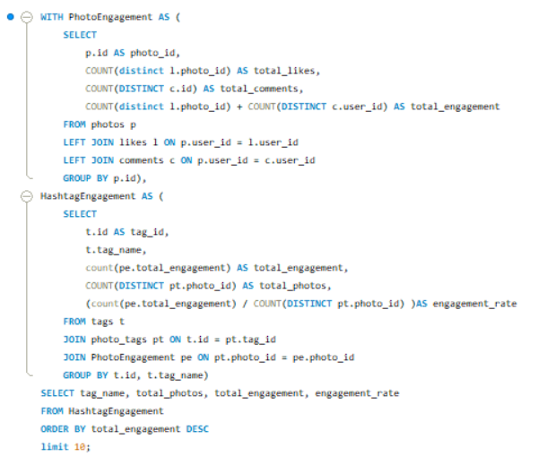
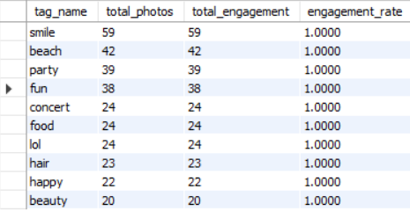

Hashtags or topics that have the highest engagement rates are those tags which have been used the most in posts and those which have the highest engagement such as smile, beach and party. We can find the engagement rate from total uses and total engagement that shows how many times a tag is used while posting an engagement.
To find those hashtags I constructed a Query to find the total likes, total comments and total engagements of the users. Then with the help of this cte I found the hashtags that have been used in those posts.
We can use this information to promote those hashtags and motivate the users to use those tags. Below are some key points that we can follow to strategize and ad campaigns.
- Identify High-Engagement Hashtags: Analyse the data to find hashtags associated with posts that have the highest likes, comments, and shares.
- Content Strategy: Encourage users to use these hashtags by featuring them in challenges or content prompts. Create campaigns centred around trending topics or popular hashtags.
- Ad Campaigns: Use these hashtags to target ads, ensuring they align with popular topics, thereby increasing relevance and engagement. Create ads that resonate with the interests and engagement patterns of your audience.

4. Are there any patterns or trends in user engagement based on demographics (age, location, gender) or posting times? How can these insights inform targeted marketing campaigns?
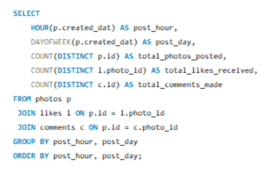
For this I constructed a Query to check the Total photos posted, total likes received on that photo, and total comments on those photos at particular time and days of week. Which gave us the following output.
Here we can see that the photos posted on the 3rd day of the week, that is Wednesday, have the most responses and engagements, So yes there is a pattern between user engagement and posting times.
For reaching to this result I followed the following Approach:
  - Analyse Time & Days Data: Look for correlations between user demographics and engagement metrics. Identify peak engagement times across different demographic groups.
  - Targeted Campaigns: Use insights to create targeted ads and content. For example, if younger users are more active in the evening, schedule posts and ads to appear during those times.
  - Content Personalization: Create content that resonates with specific demographics based on their engagement patterns. Tailor messaging and imagery to match the preferences of different groups.

5. Based on follower counts and engagement rates, which users would be ideal candidates for influencer marketing campaigns? How would you approach and collaborate with these influencers?
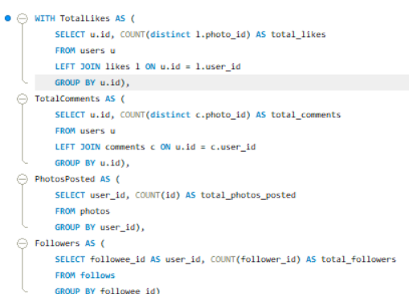
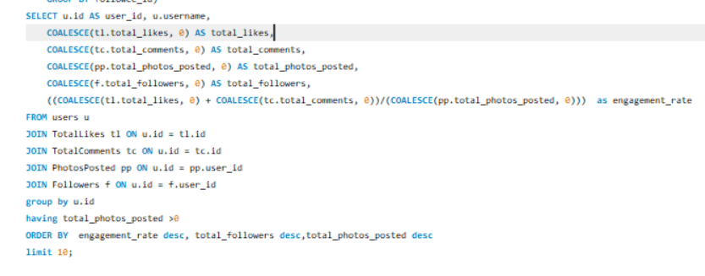
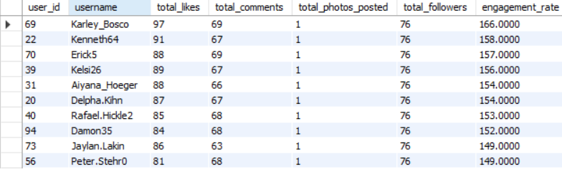

To find the users who would be ideal candidates for marketing campaigns first we have to find the users with most engagements. To find those users with the most engagement, I constructed a Query to find the top 10 users who have the highest engagement rate and most number of followers.
In this Query I used ctes to find the users with highest number of followers and then among those users who have highest engagement rates. By calculating total likes, total comments on their posts and limited the result to only top 10 users. With this I got top 10 users who are influential among all.
The Approach for this problem statement:
- Identify Potential Influencers: Look for users with high follower counts and strong engagement rates. Prioritize those whose content aligns with your brand values and target audience.
- Collaboration Strategy: Reach out with a clear value proposition—what they gain from partnering with you. Offer opportunities like product collaborations, sponsored content, or exclusive access to events or features.
- Relationship Building: Foster long-term relationships with influencers rather than one-off campaigns. Consider offering affiliate programs or ambassador roles.

6. Based on user behavior and engagement data, how would you segment the user base for targeted marketing campaigns or personalized recommendations?
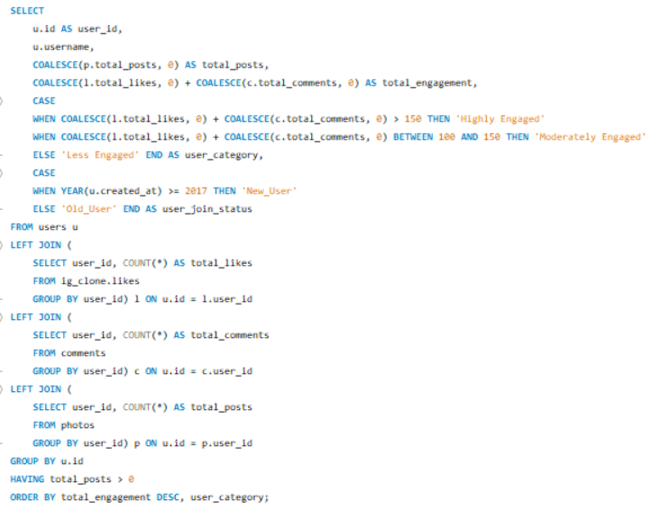
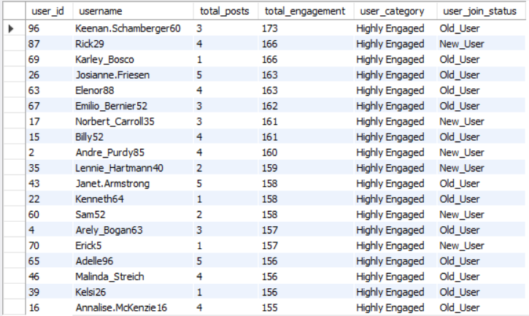

Based on user behaviour and engagement data I classified the users in Three main segments that are ‘Highly Engaged’ , ‘Moderately Engaged’ and ‘Less Engaged’. Based on their Engagements. If the user has a total of engagements more than 150 then they are considered as ‘Highly Engaged’ and if the users have total engagement between 100 and 150 then they are classified as ‘Moderately Engaged’ at last if the users have engagement rate less than 100 the are considered ‘Less Engaged’.
I furthermore classified the user in two more segments on the basis of time period of their account, if the account has been created in or after 2017 then they are called ‘New User’ and those users who created their account before 2017 are called ‘Old Users’. These classifications will help us in targeted marketing and personalized recommendations.
For this Query I used the Cte and Joins concept that I used before for finding the total likes and total comments and total engagements of the users. Then using the CASE function I classified these users on the basis of total engagements and on the basis of account creation year.
This Query gave us the following result and the names of users with the segment they fall in.

The approach that I followed in this problem statement are:
- Segmentation Criteria: Segment users based on engagement levels, content preferences and time period on website (e.g., frequent likers, commenters, or content creators).
- Targeted Marketing: Create different marketing strategies for each segment. For example, offer personalized recommendations for frequent shoppers or exclusive content for top engagers.
- Personalization: Use segmentation to personalize user experiences on the platform, such as personalized feeds, content suggestions, or targeted notifications.
7. If data on ad campaigns (impressions, clicks, conversions) is available, how would you measure their effectiveness and optimize future campaigns?
To measure the effectiveness of ad campaigns, it's important to analyze various metrics that provide insights into how well the campaign is performing in reaching and engaging the target audience. The aim is to not only evaluate the campaign's performance but also to use this information to optimize future campaigns for better results.
Measuring Effectiveness:
- Impressions: High impressions indicate good visibility. However, impressions alone don't tell the full story of effectiveness. They need to be analyzed in conjunction with other metrics like clicks and conversions.
- Clicks: A higher Click Rate suggests that the ad content, creative, and targeting are compelling and relevant to the audience. Low Click Rate might indicate that the ad is not engaging or that it is being shown to the wrong audience.
- Conversion Rate: A high conversion rate indicates that not only are users interested enough to click the ad, but they are also motivated to take further action. A low conversion rate could point to issues with the landing page, the offer, or the overall user experience.
- Engagement Metrics: High engagement indicates that the ad content resonates with the audience, which can increase brand awareness and loyalty, even if it doesn't immediately lead to conversions.
Optimizing Future Campaigns:
- Testing: Test different versions of your ad (e.g., headlines, images, calls to action) to see which performs better. Use the results to refine future ads. If one version of an ad has a higher Click Rates or conversion rate, focus more resources on that approach.
- Refining Targeting: Analyze which audience segments (age, gender, location, interests) are responding best to your ads. Adjust targeting to focus on high-performing segments. If data shows that a particular demographic converts at a higher rate, allocate more of your ad budget towards reaching this group.
- Optimizing Ad Platforms: Evaluate which platforms or ad placements (e.g., social media, search engines, websites) are generating the best results. If ads perform better on a particular platform or time of day, shift your ad spend to maximize visibility during those peak times or locations.
- Utilizing Retargeting: Use retargeting to show ads to users who have previously interacted with your brand but didn’t convert. If data shows a significant drop-off after the initial interaction, retarget those users with personalized ads to encourage them to complete the conversion.
By systematically measuring the effectiveness of our ad campaigns using these metrics and strategies, we can make data-driven decisions to optimize future campaigns, ensuring higher engagement, conversions, and overall return on investment.
8. How can you use user activity data to identify potential brand ambassadors or advocates who could help promote Instagram's initiatives or events?
We have the categories Highly Engaged, Moderately Engaged and Less Engaged so now we will see which of these users are highly engaged, have more followers and regularly posting, we will prioritize them as potential brand ambassadors or advocates. Here's how we can leverage user activity data for this purpose:
- Identify Highly Engaged Users: Track users with a consistently high engagement rate, which includes frequent likes, comments, shares, and story interactions. These users are actively involved with the content and show genuine interest in the brand. Identify users who frequently share the brand’s content or mention the brand in their posts and stories. Sharing indicates that they are not only engaging but also helping to amplify the brand’s message.
- Analyze Influence and Reach: Look for users with a significant number of followers, as they have the potential to reach a larger audience. While follower count alone isn't sufficient, it’s a good starting point. Identify whether the user is already an influencer within a relevant niche. Influencers who align with the brand’s values can effectively promote initiatives or events.
- Monitor Content Quality and Alignment with Brand Values: Review the type of content the user regularly posts. Are they creating content that aligns with the brand’s image and values? For instance, if Instagram is promoting a wellness event, users who frequently post about health, fitness, or mindfulness could be ideal ambassadors. Look for users who demonstrate creativity and originality in their posts. High-quality, visually appealing content can enhance the brand’s image when shared.
- Track Loyalty and Long-Term Engagement: Identify users who have been consistently engaging with the brand over an extended period. Long-term engagement indicates loyalty and a deeper connection to the brand. Look for users who have already advocated for the brand in the past without any incentive. Their genuine support makes them strong candidates for formal ambassador roles.
- Evaluate Potential for Authentic Advocacy: Assess whether the user’s interactions with the brand appear genuine or if they are merely engaging for incentives (e.g., giveaways). Authenticity is key to effective brand ambassadorship. Analyze any user-generated content where the individual shares personal experiences with the brand’s products or services. Testimonials can indicate a strong connection to the brand, making them more credible as advocates.
- Reach Out and Engage Potential Ambassadors: Engage with these users directly through comments, likes, or direct messages. This can help establish a relationship and assess their willingness to collaborate. Offer them opportunities to participate in exclusive events, beta tests, or product launches. This not only strengthens the relationship but also provides a platform for them to naturally promote the brand.

9. How would you approach this problem, if the objective and subjective questions weren't given?
Well, certainly the Objective and Subjective questions were helpful as they provided a clear outline and a better understanding of the problems, as well as the methodology to reach the solutions. But if those questions were not provided, I would have followed a structured analytical approach to derive insights from the given dataset.
The approach and steps would be as follows:
- Problem Identification: I would begin by understanding the primary goals of the analysis—whether the objective is to improve user engagement, increase retention, enhance content performance, or identify potential influencers. Based on this clarity, I would outline the strategy and determine which data points and analytical methods need to be prioritized.
- Data Exploration: Next, I would conduct an initial exploratory analysis to understand the data structure, distribution, relationships, and any early trends. This step also helps determine whether the raw data is sufficient to draw insights or if deeper processing is required.
- Data Cleaning and Validation: I would then move to preparing the data for analysis. This includes checking for null values, duplicates, inconsistencies, and incorrect entries across all tables. Once identified, these issues would be corrected to ensure accuracy and reliability in the upcoming analysis.
- Trend Formation & Hypothesis Building: Using initial observations and business understanding, I would form hypotheses such as “Users with consistent engagement have higher retention” or “Users with strong follower activity may be potential influencers.” These hypotheses would guide deeper analysis and help focus on relevant user segments.
- Data-Driven Analysis & Validation: At this stage, I would run SQL queries and analytical operations to validate or reject the hypotheses. This would reveal the actual behavioural patterns and highlight how current trends align or differ from expected goals.
- Insight Generation & Reporting: Finally, I would compile the findings into a structured report summarizing the current scenario, key insights, strengths, and areas that require improvement. These insights would help management understand user behavior better and take informed actions to optimize performance and strategy.
10. Assuming there's a "User_Interactions" table tracking user engagements, how can you update the "Engagement_Type" column to change all instances of "Like" to "Heart" to align with Instagram's terminology?
For this problem first I created a new Table User_Interactions with the following Query.
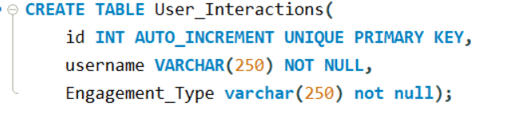
After creating the User_Interaction table then I entered values in the table taking from the original table data.
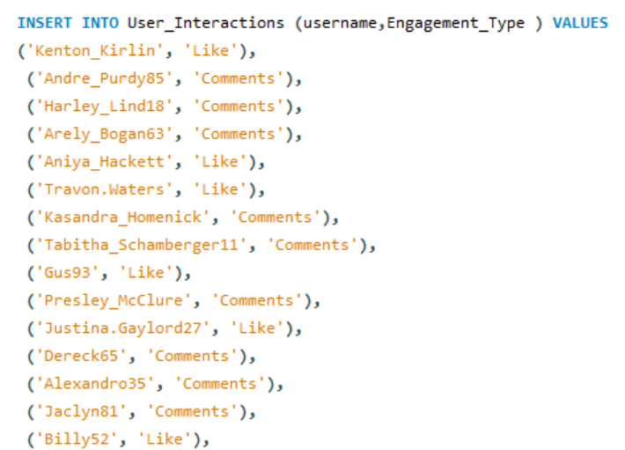
Finally for updating the values in the table User_Interaction which was the original problem statement I constructed the following SQL Query
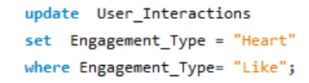
From the above query I got the desired output updating the "Engagement_Type" column to change all instances of "Like" to "Heart" to align with Instagram's terminology.

